**How to create Phi Environment**



# Scope of the document

This document contains fast instruction to setup designer and runtime environment. The instruction are tailored on basic installation, and most common request.

# Phi Environments

Phi is divided in two main environment: Designer and Runtime environment.

The Designer environment is used to create Phi Solutions and deploy them in a runtime environment, and it’s based on Eclipse IDE.

Runtime Environment it’s used to run the Phi Solutons. It’s based on JBoss application server.

Both Runtime and Designer environments need databases to work. In particular the runtime. The designer need the db only to configure it: the designer is used infatc to create the dictionaries (containing coded values) used by the Runtime.

# Designer environment.

Phi Designer environment it’s created by installing a clean Eclipse 3.7.2 classing and after that adding the needed plugins. Some of them (like sub-eclipse) are third party vendor plugins, and for the support about them, like for eclipse support you are invited to follow the vendor support.

There are two ways to create a Phi designer environment: Through update site, or by installing manually the plugins into eclipse.

In both case start with installing eclipse:

1. Download Eclipse Classic 3.7.2 from Eclipse site. Actually, jenuary 2013, can be found at: <http://www.eclipse.org/downloads/packages/eclipse-classic-372/indigosr2>

You have to take the 32 bit version.

If you already have an Ecplise Classic 3.7.2, you should be able to install using your previous eclipse installation, please continue in this case to paragraph 2.2.

1. Unzip the the downloaded file in a folder, and start ecplise executable.
2. Select a workspace where you like to store your project folders, and close the main

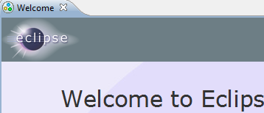

## Automatic procedure with update site.

1. Open Help menu and choose “Install New Software..”. In the new window, type in the site file the following url: <http://support.insielmercato.it/designerDownload/> **[url not active]**

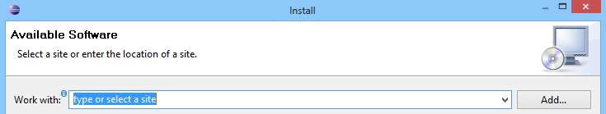

1. If your internet connection is available and the Phi Update Site is reachable, you should see a list similar to the following picture. Please do not type any filter, and press the “Select All” button.

Tip: if you are using an already existing eclipse installation, some of this package can be already present in your system (e.g. subEclipse).

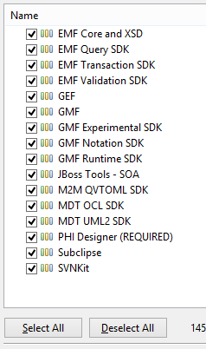

After that click on “Available Software Sites” on the right up corner of the window

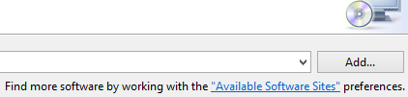

Deselect please the voice “The Eclipse Project Updates” from available sites list and press OK.

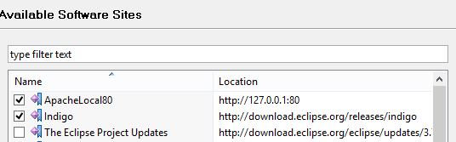

1. Follow the wizard instruction (you should go through two other windows with next), finally you must accept the license agreement and press Finish.



1. The installation will start, and it will take some minutes. The time needed can depends also by your internet connection bandwidth and by your machine resources.

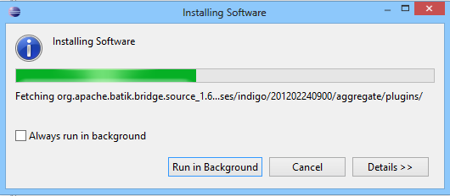

During the installation you will asked to confirm to install not signed content . Please agree on that clicking OK

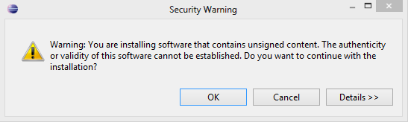

1. At the end of installation process an Eclipse restart is needed. Please “Restart now”

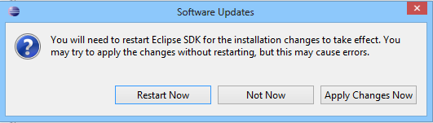

## Manual procedure to install designer

The designer environment can be provided by a Zip file, with already installed standard plugins. This solution is faster in case you do not want wait time to download and install components.

In this case two zip files are provided: Designer.XX.zip and dropins.YY.zip

The two archive must be unzipped, to obtain a working designer.

1. Unzip the designer zip in a folder, like C:\phi2\ . This archive contains eclipse and basic plugins like jbpm and subeclipse
2. Unzip the dropins folder inside the designer folder. There is already present an empty dropins folder. This Archive contains the plugin produced by Phi Technology developer to obtain designer environment
3. Start eclipse with debug-eclipse.bat. This operation is needed to clean the eclipse plugin list. After started, you are required to select a workspace, please select one, and than when the starting is completed close the designer again.
4. Than you can start Eclipse normally, with Eclipse.exe executable.

## Complete Designer environment

Choose a workspace where you want to work. This is the folder where your project files will be stored.

The first question asked by Eclipse regards SubEclipse plugin. You can choose what you prefers, to send or not with your usage report to Subeclipse project.

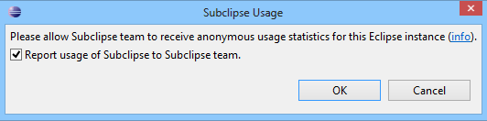

Finally add the two perspectives “Phi Designer” and “Phi Dictionary Manager” to your workspace, selecting them with the menu: Window – Open Perspective – Other:

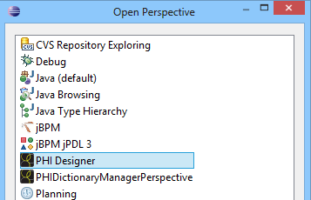

We suggest to add to the PHI Designer perspective the following view (Window – Show view): “Catalog Explorer”, “Ant” and (if missing) “Process and Rule Explorer” and “Gui Navigator”.

## Phi Dictionary Manager and coded values

Phi designer allows to manage db coded values directly from Designer environment.

Coded value are used to set pre-defined values for list of code, like list of “encounter type” (“day hospital”, “Ambulatory”, ..) which can be “coded” in the db, instead of hard coded in the application code.

Using coded values the list of code contained in a dictionary can be changed at runtime, dynamically, whitout change the application, and this operation can be done with Dictionary Manager.

The perspective “Phi Dictionary Manager” allows to connect to a db with PHI schema, and edit/add/remove coded value.

The Coded value are divided in the following way:

**Code System**: is a container of domains. A code system contains in general one or more dictionary related to a specific argument. Example of Code Systems are “Comuni” (containing data of Italian cities) and “HL7” (containing standard HL7 code).

**Domains**: is a ‘sub folder’ of a code System. The coded values contained in a Code System are structured per Domains. Each domains can contains one or more sub domains, and also coded values. Each domains represent a Dictionary.

**Coded value**: is the leaf element of each domain. It consist of an element, rapresented by an unique id, and a representative oid. It can be versioned, like an entire dictionary, and multiple version of the same code, has same oid, but different id.

Important properties of a code element are:

* **Code**: the code rapresentig the code itself, for example “M” for Male and “F” for Female.
* **Display Name**: is a representation of the code, that will be see at design time, to identify the code.
* **Translation**: is the representation of the code at runtime. Each code will be see in the browser as its translation, depending of the selected language by the final user
* **Code Extensions**: used to add additional information to a code, reprented by extension and its value. For example “population” extension contains the number of resident of a city.

## Phi Dictionary Manager connections

The connection can be added if the DB schema is already created. So please follow the instruction contained in Runtime Environment Setup chapter, to add the db schema properly.

To add a connection choose the ADD button:



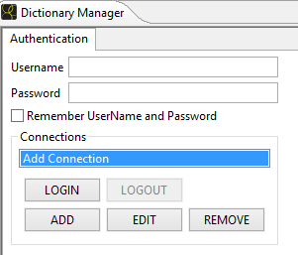

In the new connection wizard, please configure dialect/url/username/password properly.

For the connection name you are free to select a name according to your need.

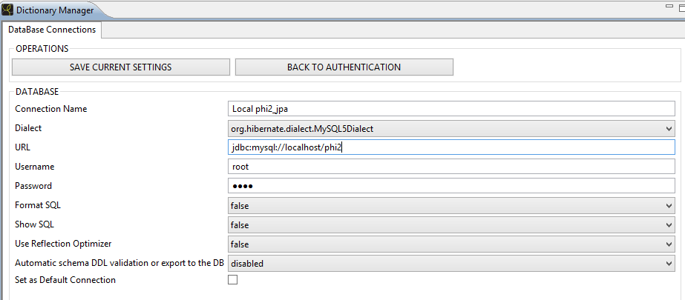

# Runtime Environment

Runtime environment is an application server (Jboss) where the phi core application is deployed, and than where you will deploy your solution produced with the Designer. Jboss when start will connect to the database needed (see next paragraph) and read the Catalog Server (base phi application framework) and the solution deployed on the server.

Runtime environment is composed by Jboss EAP 4.3.0 GA CP 07 of Red Hat Jboss. It can anyway be used a Jboss 4.2.3 of community edition, but we suggest to use the Red Hat version provided because additional packages (e.g. Jbpm, hibernate, seam, richFaces, envers) are already installed, otherwise they must be installed manually.

Unzip the provided zip in a folder, where you want to have the application server placed. (e.g. C:\phi2\)

Inside jboss you will find in \server\ all the server available, default server pre-configured server is \server\production server, and in the same folder you can find ProductionDefault.zip. This zipped server is simply a copy of production, can be used to create additional server.

To start jboss you can find in \bin\ folder a phi2.bat file containing the following instruction:

run.bat -b 0.0.0.0 -Djboss.partition.name=PHI -u 233.11.11.12 -c production

run.bat is a batch file provided with jboss, to start jboss itself. The additional switch added take this meaning:

-b 0.0.0.0 start listening on all network interfaces

-Djboss.partition.name: is the name of clustered partitions, please use a singular name for your installation to above clustering with other colleagues, if you work in team.

-u 233.11.11.12: is the ip of broadcast for clustered member discover. As switch above please use a different ip like 233.x.y.z to above clustering

-c production: the name of the server to be starded.

During development time, we suggest to above clustering, because each single developer use its proper implementation. During integration test (or in a common test environment before integration), we suggest to configure the clustering.

Clustering configuration instruction are not in scope of this document.

## Prepare db

Phi and jboss uses different db at runtime. The db connection in jboss application server are defined with “data source” files.

Jboss needs JBOSSDB-ds datasource, which is placed in \server\production\deploy folder.

Phi solution need one data source, phi-ds datasource, placed in \server\production\deploy-apps folder.

The phi solution ds contains also jbpm schema, which can be placed, if required in a separate schema.

Schema of all these db are provided in Catalog Server project, under \CATALOG_SERVER\src\main\resources\

There you can find sql script for mysql and oracle dbms, to create schema of these dbs.

In general a db dump, to simplify the final user is provided to above overwork in a test environment.

## Deploy Catalog server

From designer you must use Ant to deploy your solution and Catalog Server.

Catalog Server must be deployed only one time, to configure properly the server. Use deploy all ant task to deploy it.

Ant task use a configuration file to know the db connections and the folder path, plus some other properties. Please before run the ant task, configure build.properties file and mySql.build.properties or oracle.build.properties

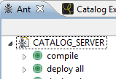 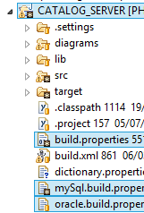

## Create a new solution

To create a new solution please use the create a new Project wizard.

Select file -> new -> other and choose in the window PHI -> PHI Project Wizard

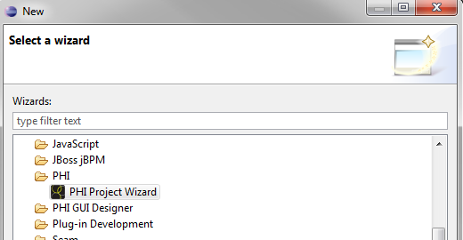

The following step ask a name for the phi solution. Provide a name according to your project.

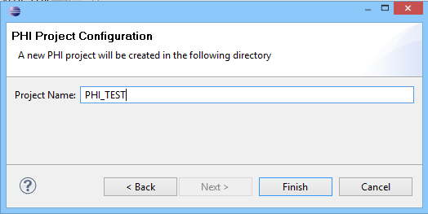

The result is a new project visible in Phi Project Wizard.

## Deploy solution

Add to ant task (+Ant) a build file taken from the new project, or from an existing project you want to deploy.

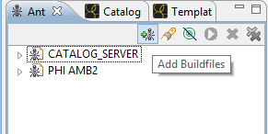

Configure build.properties file and mySql.build.properties or oracle.build.properties contained in your solution project

After that you can use the Ant task “**deploy all**” to deploy all the configuration on jboss for your new solution

The next time you edit/change yuour solution, you do not need to use deploy all task. You can use:

* **“deploy Backend”**, if you change backend java classes. Need jboss restart.
* “**deploy forms+reports+processes+dashboard**” if you changed a process. This need a logout/login to see changes in process.
* “**deploy forms+reports**” if you changed only forms or reports. This changes are taken immediately (need of course a page reload).

## Start jboss

Finally you can start jboss. Jboss will start Catalog Server application, and the Solution you deployed. If everything goes well, you can access to login page through:

[http://localhost:8080/<ProjectName>/common/jsp/login.seam](http://localhost:8080/%3cProjectName%3e/common/jsp/login.seam)

for example: <http://localhost:8080/PHI_AMB/common/jsp/login.seam>

## First user creation

The user allowed to access to the application, must be of course inserted in the system, on the database.

All the solution can use the module “MOD_Employees” to manage employees, and so add/remove users, change passwords and so on.

But the first user must be inserted manually with a java main class, provided in catalog server. The class name is EmployeeCreator.java, and need to be configured in it: username/password , domain and code of the role that must be added.